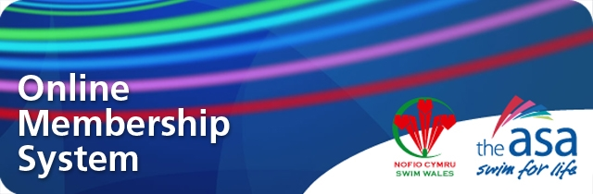

ONLINE MEMBERSHIP SYSTEM
WORKSHOP BOOKING FORM – VIRTUAL WORKSHOPS

Name:

Email:

Club Name:

Role within club:

Workshop: Please select just one

Monday 5th December, 7pm start

Wednesday 7th December, 7pm start

Data Protection Statement:
The ASA will use your personal data for the purpose of your involvement in the Online Membership Workshop and I understand that by submitting this form, I am consenting to receiving information about the Online Membership Workshop by email,

Please return your form to rachel.washington@swimming.org

